# Exercises about representation of information

**Add a few explanations to demonstrate how to perform each conversion. For example, from decimal to binary we use powers and then explain the corresponding operations.**

1. Convert from decimal to binary:
   1. 234 - 11101010
   2. 555 - 1000101011
   3. 12321 - 11000000100001
   4. 152 - 10011000
   5. 32768 - 1000000000000000

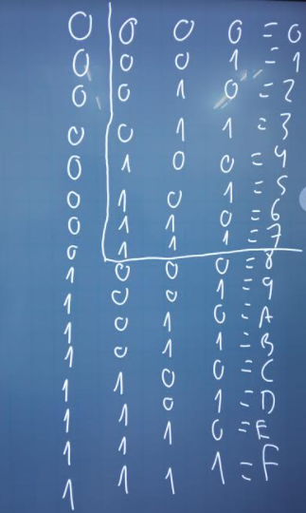

1. Convert from binary to decimal:
   1. 100000000 - 256
   2. 1011110100 - 756
   3. 10011101 - 157
   4. 11111111111 - 2047
2. Convert from hexadecimal to binary:
   1. 45A0 - 0100010110100000
   2. CF - 11001111
   3. AAB2 - 1010101010110010
   4. 3020 – 0011000000100000
3. Convert from binary to hexadecimal:
   1. 000110001000 - 188
   2. 000100010110 - 116
4. Complete the following conversions related to octal numeral system:
   1. Convert the numbers from exercise 4 to octal.
      1. 610
      2. 426
   2. Convert the octal 3020 to binary: 11000010000
5. Fill in the gaps, using all the conversions you need. You have to write the steps to transform each number.

|  |  |  |  |
| --- | --- | --- | --- |
| **BINARY** | **DECIMAL** | **HEXADECIMAL** | **OCTAL** |
| 100001 | **33** | 21 | 41 |
| 11111111 | 255 | **FF** | 377 |
| 11111111 | 255 | FF | **377** |
| **10 0001** | 33 | 21 | 41 |

1. How many bits do you need to represent the following numbers in binary?
2. hexadecimal: 4B, 4AA, FF4FA, 345F
   1. 7 bits
   2. 11 bits
   3. 20 bits
   4. 14 bits
3. decimal: 100, 256, 255, 32, 31, 3, 4350, 1024, 45, 230 , 63
   1. 7 bits
   2. 9 bits
   3. 8 bits
   4. 6 bits
   5. 5 bits
   6. 2 bits
   7. 13 bits
   8. 11 bits
   9. 6 bits
   10. 31 bits
   11. 6 bits
4. Solve the following parts using ASCII extended (8 bits).
   1. Write a random text, which contains letters, numbers and other alphanumeric characters.
   2. Encode to hexadecimal, according ASCII table.
   3. Convert to binary.